**FIȘĂ DE LUCRU: INFORMATICĂ APLICATĂ -LAB.5STRUCTURA APPLICATIILOR WEB-INTERNET. LIMBAJE DE MARK-UP (HTML, XML).** (Head, title, culoare:blue, align:center; font arial)

**(Body)**

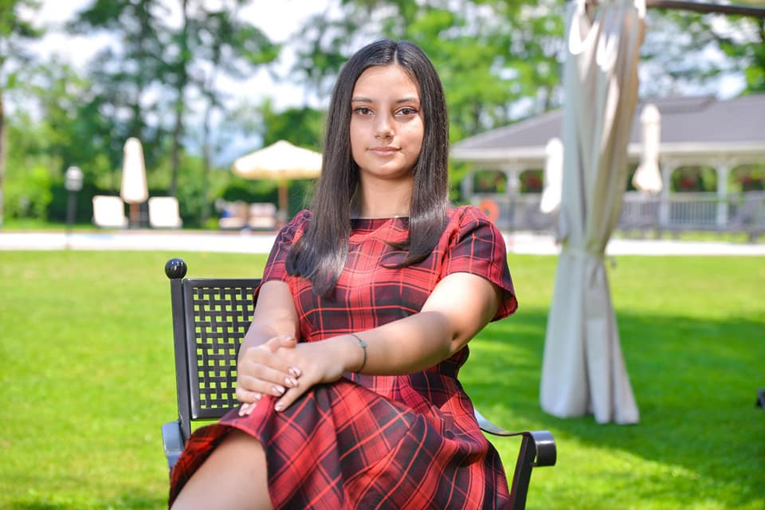

**0.**

**imagine**

Ciucă Andreea-Carmen (paragraph)

Email: [Ciuca.Al.Andreea@utcluj.didatec.ro](mailto:Ciuca.Al.Andreea@utcluj.didatec.ro) (paragraph)

**“**When given the choice between being right or being kind choose kind.**”** “Wonder”(paragraph, culoare:red; font:calibri; size:12, align: center)

(lista, font Bahnschrift Light Condensed; size:14)

1. Fizica Superioara Anul 1: <https://etti.utcluj.ro/files/FiseDisciplina/EaRo/10.pdf>
2. Teoria circuitelor electrice anul 1: <https://etti.utcluj.ro/files/FiseDisciplina/EaRo/13.pdf>
3. Grafica asistata pe calculator anul 2:<https://etti.utcluj.ro/files/FiseDisciplina/EaRo/17.pdf>

**Lista Hobby: Citit, Scris, Cantat la chitara.(paragraph)**

**Educatie**

|  |  |  |
| --- | --- | --- |
| *Colegiul National “Mircea cel Batran”* | *2016-2020* | *Matematica Informatica* |
| *UTCN* | *2020-* | *ETTI* |

(table)